 | 7.3.16 Editors - 3D Viewport - Sidebar - Tool Tab - Hair Curve - Sculpt Mode
Table of content
Detailed table of content 1
Sculpt Mode 5
Brush Asset Panel 5
Brush Settings Panel 6
Brush Settings Panel - Comb 8
Brush Settings Panel - Grow/Shrink 8
Brush Settings Panel - Pinch 9
Brush Settings Panel - Puff 9
Brush Settings Panel - Pull Tip 9
Brush Settings Panel - Slide 9
Brush Settings Panel - Smooth 10
Brush Settings Panel - Add 10
Brush Settings Panel - Delete 11
Brush Settings Panel - Density 11
Brush Settings Panel - Select 12
Stroke Sub panel 12
Falloff Sub panel 17
Cursor Sub panel 18
Symmetry panel 18

Detailed table of content
Detailed table of content
Detailed table of content 1
Sculpt Mode 5
Brush Asset Panel 5
Browse Brush 5
Brush Specials menu 5
Edit Metadata 5
Catalog 5
Author 5
Desctription 6
OK / Cancel 6
Edit Preview Image 6
Save Brush Asset 6
Revert Brush Asset 6
Name 6
Brush Settings Panel 6
Use unified size 6
Use Pressure 6
Pressure Size Curve 7
Selecting Points 7
Adding Points 7
Navigation elements 7
Zoom in 7
Zoom out 7
Clipping options 7
Tools 7
Reset View 7
Reset Curve 7
Handles 8
Position X / Y 8
Delete Points 8
Curve Presets 8
Brush Settings Panel - Comb 8
Size 8
Strength 8
Brush Settings Panel - Grow/Shrink 8
Size 8
Strength 8
Direction 8
Scale Uniform 8
Minimum Length 9
Brush Settings Panel - Pinch 9
Size 9
Strength 9
Brush Settings Panel - Puff 9
Size 9
Strength 9
Brush Settings Panel - Pull Tip 9
Size 9
Strength 9
Brush Settings Panel - Slide 9
Size 10
Strength 10
Brush Settings Panel - Smooth 10
Size 10
Strength 10
Brush Settings Panel - Add 10
Size 10
Strength 10
Count 10
Interpolate 10
Length 10
Size 10
Shape 10
Point Cloud 11
(Curve) Length 11
(Curve) Size 11
Points (per Curve) 11
Brush Settings Panel - Delete 11
Size 11
Brush Settings Panel - Density 11
Size 11
Strength 11
Count Max 11
Interpolate 11
Length 11
Size 11
Shape 12
Point Cloud 12
(Curve) Length 12
(Curve) Size 12
Points (per Curve) 12
Brush Settings Panel - Select 12
Size 12
Strength 12
Direction 12
Stroke Sub panel 12
Use Pressure 13
Pressure Size Curve 13
Selecting Points 13
Adding Points 13
Navigation elements 13
Zoom in 13
Zoom out 13
Clipping options 13
Tools 13
Reset View 13
Reset Curve 14
Handles 14
Position X / Y 14
Delete Points 14
Curve Presets 14
Stroke Method 14
Dots 14
Jitter 14
Jitter Unit 14
Input Samples 14
Stabilize Stroke subpanel 14
Size 14
Factor 14
Space 15
Spacing 15
Dash Ratio 15
Dash Length 15
Jitter 15
Jitter Unit 15
Input Samples 15
Stabilize Stroke subpanel 15
Size 15
Factor 15
Airbrush 15
Rate 15
Jitter 15
Jitter Unit 16
Input Samples 16
Stabilize Stroke 16
Size 16
Factor 16
Line 16
Spacing 16
Dash Ratio 16
Dash Length 16
Jitter 16
Jitter Unit 16
Input Samples 16
Curve 16
Spacing 16
Paint Curve Data 17
Dash Ratio 17
Dash Length 17
Jitter 17
Jitter Unit 17
Input Samples 17
Falloff Sub panel 17
Curve Preset 17
Zoom In 17
Zoom Out 17
Clipping Options 17
Reset View 18
Reset Curve 18
Presets 18
Cursor Sub panel 18
Show Brush 18
Cursor Color 18
Falloff Opacity 18
Override Overlay 18
Use Cursor Overlay 18
Symmetry panel 18

Sculpt Mode

In Sculpt mode you can sculpt the hair curves.

Brush Asset Panel
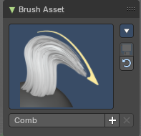
The Brush Asset Panel contains the different Brushes and some Brush settings. Choose and adjust your current active brush.

Browse Brush
The big image at the top is a dropdown box that allows you to choose a brush. Click at it, and you will see the different brushes. A click at one of the images will choose this brush then.
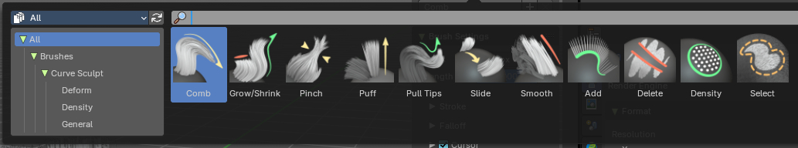
Brushes are assets. You can load them from different libraries if you want.

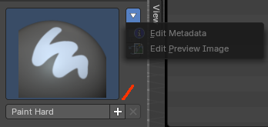
Brush Specials menu
This menu becomes active when you create a new brush. Which can be done wiht the Plus button in the name property. This data cannot be changed for builtin system brushes.

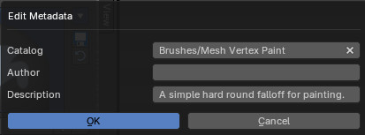
Edit Metadata
Calls a popup where you can adjust further informations and settings for the brush.

Catalog
The asset catalog in which the brush is stored.

Author
The brush author.

Desctription
Add a description

OK / Cancel
Accept or decline the changes.

Edit Preview Image
Allows you to load a custom preview image.

Save Brush Asset
This button is just active with a custom brush. It saves all changes made at the brush settings into the current custom brush.

Revert Brush Asset
Reverts the brush settings to the default values of the brush in the asset library.

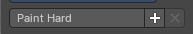
Name
The edit box below the Image shows the name of the current active brush.
The + button allows you to add a new pencil with the current settings. Note that the brushes are NOT automatically saved when you close Bforartists. You need to save the brush asset. See above.
The X button deletes the brush from the brushes list and from the asset library. This button is just active with a custom brush. You will be prompted by a warning so that you don't accidentally remove the brush.

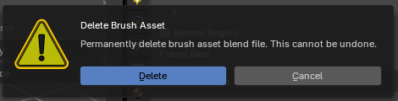

Brush Settings Panel

Use unified size
The size is shared across the brushes.

Use Pressure
The button behind the edit box enables tablet pressure sensitivity for strength.

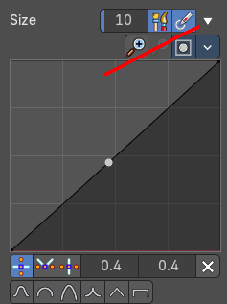
Pressure Size Curve
Behind the pressure size button there is a button to reveal the size pressure curve panel. When you activate Size Pressure for tablets, then the Size Pressure curve becomes active, and can be adjusted.
The pressure size curve allows you to adjust the falloff curve for the tablet pressure. It shows when Use Pressure is activated. The curve panel shows when clicking at the button.


Selecting Points
You can select curve points. This reveals two edit boxes for the x and y coordinate of this point.
Selected points can be moved around. Left click at them, hold the mouse button down and move them to a new location.


Adding Points
You can add new curve points by simply left clicking at the curve. Move the mouse to position them where you need it.

Navigation elements

Zoom in
Zooms in.

Zoom out
Zooms out.

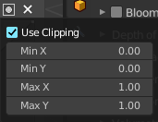
Clipping options
Set up clipping for the stroke.

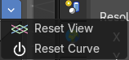
Tools
Tools is a menu where you can find some curve related tools.

Reset View
Resets the curve windows zoom.

Reset Curve
Resets the curve to the initial shape.

Handles
You can choose between Auto handle, Vector Handle and Auto Clamped.

Position X / Y
The position of the selectedc curve point.

Delete Points
Deletes the selected curve point.

Curve Presets
A curve preset to start with.

Brush Settings Panel - Comb

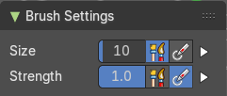
Size
The Size of the brush.

Strength
The strength of the brush.

Brush Settings Panel - Grow/Shrink

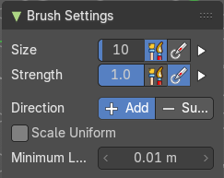
Size
The Size of the brush.

Strength
The strength of the brush.

Direction
Add or subtract the effect of the brush. Add grows hair curves, Subtract shorten the hair curves.

Scale Uniform
Grow or shrink curves by changing their size uniformly instead of using trimming or extrapolation. This is useful for preserving control point count.

Minimum Length
Avoids shrinking curves shorter than this length.

Brush Settings Panel - Pinch

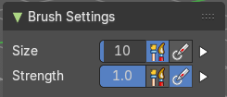
Size
The Size of the brush.

Strength
The strength of the brush.

Brush Settings Panel - Puff

Size
The Size of the brush.

Strength
The strength of the brush.

Brush Settings Panel - Pull Tip

Size
The Size of the brush.

Strength
The strength of the brush.

Brush Settings Panel - Slide

Size
The Size of the brush.

Strength
The strength of the brush.

Brush Settings Panel - Smooth

Size
The Size of the brush.

Strength
The strength of the brush.

Brush Settings Panel - Add
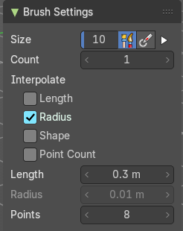

Size
The Size of the brush.

Strength
The strength of the brush.

Count
Number of curves added by the add brush.

Interpolate

Length
Use length of the curve in close proximity.

Size
Use Size of the curve in close proximity.

Shape
Use shape of the curve in close proximity.

Point Cloud
Use the number of points from the curve in close proximity.

(Curve) Length
Length of the newly added curves when it is not interpolated from other curves.

(Curve) Size
Size of the newly added curves when it is not interpolated from other curves.

Points (per Curve)
Number of control points in a newly added curve.

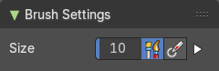
Brush Settings Panel - Delete

Size
The Size of the brush.

Brush Settings Panel - Density

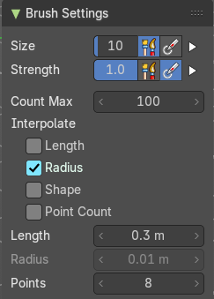
Size
The Size of the brush.

Strength
The strength of the brush.

Count Max
How many times the density brush tries to add new curves.

Interpolate

Length
Use length of the curve in close proximity.

Size
Use Size of the curve in close proximity.

Shape
Use shape of the curve in close proximity.

Point Cloud
Use the number of points from the curve in close proximity.

(Curve) Length
Length of the newly added curves when it is not interpolated from other curves.

(Curve) Size
Size of the newly added curves when it is not interpolated from other curves.

Points (per Curve)
Number of control points in a newly added curve.

Brush Settings Panel - Select

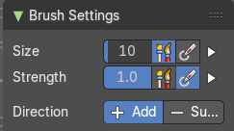
Size
The Size of the brush.

Strength
The strength of the brush.

Direction
The direction of the brush.

Stroke Sub panel

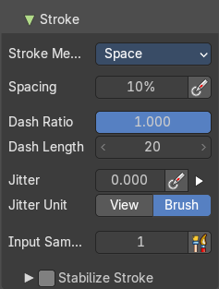
This subpanel shows with all brushes in the Brush settings panel.

Use Pressure
The button behind the edit box enables tablet pressure sensitivity for strength.

Pressure Size Curve
Behind the pressure size button there is a button to reveal the size pressure curve panel. When you activate Size Pressure for tablets, then the Size Pressure curve becomes active, and can be adjusted.
The pressure size curve allows you to adjust the falloff curve for the tablet pressure. It shows when Use Pressure is activated. The curve panel shows when clicking at the button.

Selecting Points
You can select curve points. This reveals two edit boxes for the x and y coordinate of this point.
Selected points can be moved around. Left click at them, hold the mouse button down and move them to a new location.

Adding Points
You can add new curve points by simply left clicking at the curve. Move the mouse to position them where you need it.

Navigation elements

Zoom in
Zooms in.

Zoom out
Zooms out.

Clipping options
Set up clipping for the stroke.

Tools
Tools is a menu where you can find some curve related tools.

Reset View
Resets the curve windows zoom.

Reset Curve
Resets the curve to the initial shape.

Handles
You can choose between Auto handle, Vector Handle and Auto Clamped.

Position X / Y
The position of the selectedc curve point.

Delete Points
Deletes the selected curve point.

Curve Presets
A curve preset to start with.

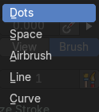
Stroke Method
Show the brush icon when painting.

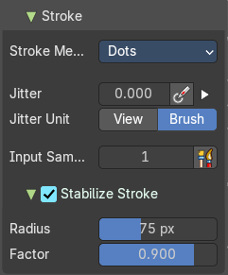
Dots
Apply paint on each mouse move step.

Jitter
The position of the brush while painting. Pressure sensitivity can be activated here.

Jitter Unit
Jitter in view in screen space or relative to brush size. Buttons are View and Brush Relatively..

Input Samples
Average multiple input samples together to smooth the brush stroke.

Stabilize Stroke subpanel
Brush lags behind the mouse and followers a smoother path when activated.

Size
Smooth stroke Size: minimum distance from the last point before stroke continues.

Factor
Smooth stroke factor: higher values give a smoother stroke.

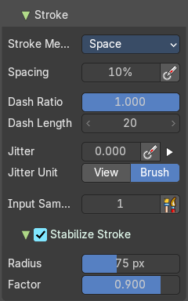
Space
Limit brush applications to the distance specified by spacing.

Spacing
Spacing between brush daubs as a percentage of a brush diameter. Pressure sensitivity activated here.

Dash Ratio
Ratio of samples in a cycle that the brush is enabled.

Dash Length
Length of a dash cycle measured in stroke samples.

Jitter
The position of the brush while painting. Pressure sensitivity can be activated here.

Jitter Unit
Jitter in view in screen space or relative to brush size. Buttons are View and Brush respectively.

Input Samples
Average multiple input samples together to smooth the brush stroke.

Stabilize Stroke subpanel
Brush lags behind the mouse and followers a smoother path when activated.

Size
Smooth stroke Size: minimum distance from the last point before stroke continues.

Factor
Smooth stroke factor: higher values give a smoother stroke.

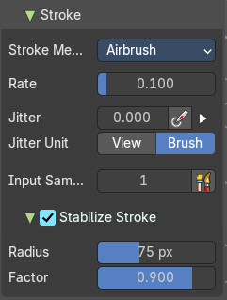
Airbrush
Keep applying paint effect while hiding mouse (spray).

Rate
Intervals between paints for airbrush.

Jitter
The position of the brush while painting. Pressure sensitivity can be activated here.

Jitter Unit
Jitter in view in screen space or relative to brush size. Buttons are View and Brush respectively.

Input Samples
Average multiple input samples together to smooth the brush stroke.

Stabilize Stroke
Brush lags behind the mouse and followers a smoother path when activated.

Size
Smooth stroke Size: minimum distance from the last point before stroke continues.

Factor
Smooth stroke factor: higher values give a smoother strok

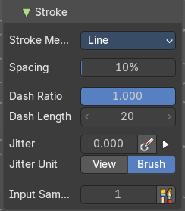
Line
Drag a line with dabs separated according to spacing.

Spacing
Spacing between brush daubs as a percentage of a brush diameter.

Dash Ratio
Ratio of samples in a cycle that the brush is enabled.

Dash Length
Length of a dash cycle measured in stroke samples.

Jitter
The position of the brush while painting. Pressure sensitivity can be activated here.

Jitter Unit
Jitter in view in screen space or relative to brush size. Buttons are View and Brush respectively.

Input Samples
Average multiple input samples together to smooth the brush stroke.

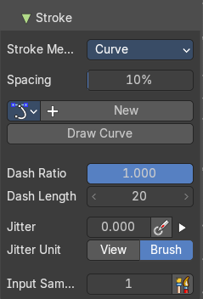
Curve
Define the stroke curve with a bezier curve. Dabs are seperated according to spacing.

Spacing
Spacing between brush daubs as a percentage of a brush diameter.

Paint Curve Data
Make new or select existing paint curve data profiles.

Dash Ratio
Ratio of samples in a cycle that the brush is enabled.

Dash Length
Length of a dash cycle measured in stroke samples.

Jitter
The position of the brush while painting. Pressure sensitivity can be activated here.

Jitter Unit
Jitter in view in screen space or relative to brush size. Buttons are View and Brush respectively.

Input Samples
Average multiple input samples together to smooth the brush stroke.

Falloff Sub panel

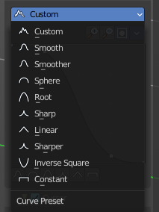
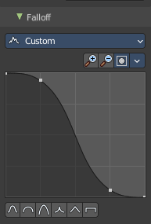
This subpanel shows with all brushes in the Brush settings panel. This customizes the fall off of the brush, where the left is the center and right is the outer circle of the brush. Higher values is stronger falloff.

Curve Preset
Select a falloff curve preset.

Zoom In
Zoom the graph in.

Zoom Out
Zoom the graph out.

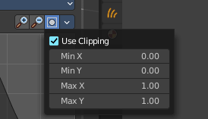
Clipping Options
Control the minimum X and Y values and maximum X and Y values.

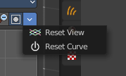
Reset View
Restore the default zoom value and center view.

Reset Curve
Reset to preset curve values.

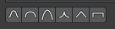
Presets
Quickly draw some default curve profiles.

Cursor Sub panel

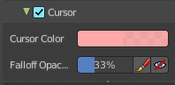
This subpanel shows with all brushes in the Brush settings panel.

Show Brush
Show the brush icon when painting.

Cursor Color
The brush icon color with adding.

Falloff Opacity
The brush icon falloff opacity. This is an overlay drawn by a percentage.

Override Overlay
When activated it won’t show the overlay when drawing.

Use Cursor Overlay
When activated, this will hide the overlay in the viewport completely.

Symmetry panel

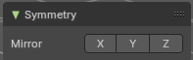
Enable symmetry sculpting for single axis.

